1956 Beocord Unitape 512 K

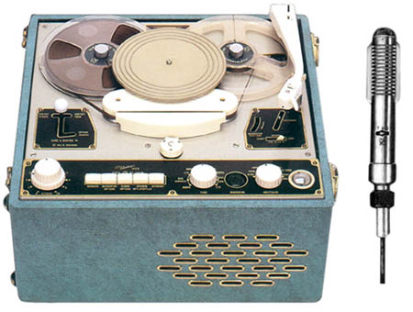 | Many thanks to Get Reel's Danish correspondent, Flemming Sorensen for the information on this page.  In the mid 50's, audio equipment was still rather expensive so B&O came up with a quite innovative idea in 1956. By combining amplifier, tape recorder, and record player in a single unit, you could save some  money.  The result was this rather awkward looking machine which I believe sold quite well. I have seen it a couple of times at antique sales but they are rather expensive nowadays.

An old technician I once spoke to told me that it was rather a popular piece of equipment in dancing schools because of its ability to do variospeed. When rehearsing the dance for the first time the music could be slowed down and then put to the correct speed when the dancers had gotten the steps right.
Last time I saw one I tried to lift it. I had to use both hands so I guess it weighs more than 15kg. Like the beocord 507 it can be used on both AC and DC voltage.

Specifications at a glance

Model | Beocord Unitape 512 K
Year | 1956
Track system | half-track mono
Heads | two
Motors | three
Maximum reel size | 7"
Tape speeds | 3¾ and 7½ ips with variospeed to compensate for voltage variations
Turntable speeds | 33, 45 and 78 rpm
Turntable pick-up | ceramic, two sided for shellac and vinyl
Inputs | radio and balanced mike (designed for the BM-3 ribbon mike in the main picture)
Outputs | Speaker, headphone and balanced line
Power consumption | 65 - 125 watts AC/DC)
Speaker(s) | oval 20 x 10cm
Dimensions | 17½ x 17½ x 7¾" (450 x 450 x 200 mm)
 | back to top

